Pie Charts

Pie charts are not recommended in the R documentation, and their features are somewhat limited. The authors recommend [bar](http://www.statmethods.net/graphs/bar.html) or [dot plots](http://www.statmethods.net/graphs/dot.html) over pie charts because people are able to judge length more accurately than volume. Pie charts are created with the function **pie(***x***, labels=)** where *x* is a non-negative numeric vector indicating the area of each slice and labels= notes a character vector of names for the slices.

Simple Pie Chart

# Simple Pie Chart  
slices <- c(10, 12,4, 16, 8)  
lbls <- c("US", "UK", "Australia", "Germany", "France")  
pie(slices, labels = lbls, main="Pie Chart of Countries")



Pie Chart with Annotated Percentages

# Pie Chart with Percentages  
slices <- c(10, 12, 4, 16, 8)   
lbls <- c("US", "UK", "Australia", "Germany", "France")  
pct <- round(slices/sum(slices)*100)  
lbls <- paste(lbls, pct) # add percents to labels   
lbls <- paste(lbls,"%",sep="") # ad % to labels   
pie(slices,labels = lbls, col=rainbow(length(lbls)),  
   main="Pie Chart of Countries")

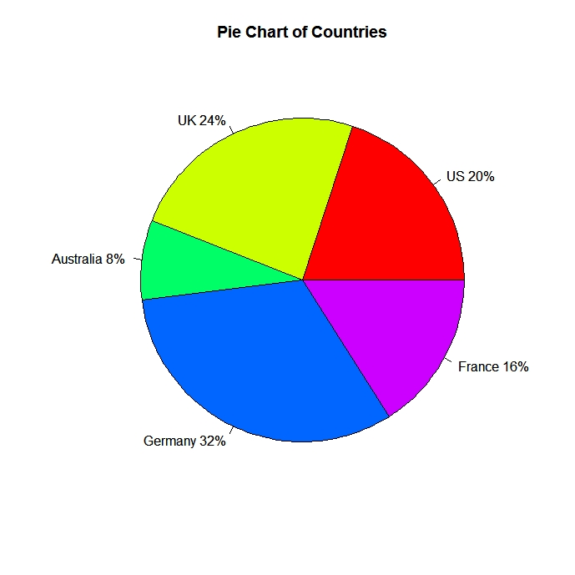

3D Pie Chart

The **pie3D( )** function in the [plotrix](http://cran.r-project.org/web/packages/plotrix/index.html) package provides 3D exploded pie charts.

# 3D Exploded Pie Chart  
library(plotrix)  
slices <- c(10, 12, 4, 16, 8)   
lbls <- c("US", "UK", "Australia", "Germany", "France")  
pie3D(slices,labels=lbls,explode=0.1,  
   main="Pie Chart of Countries ")

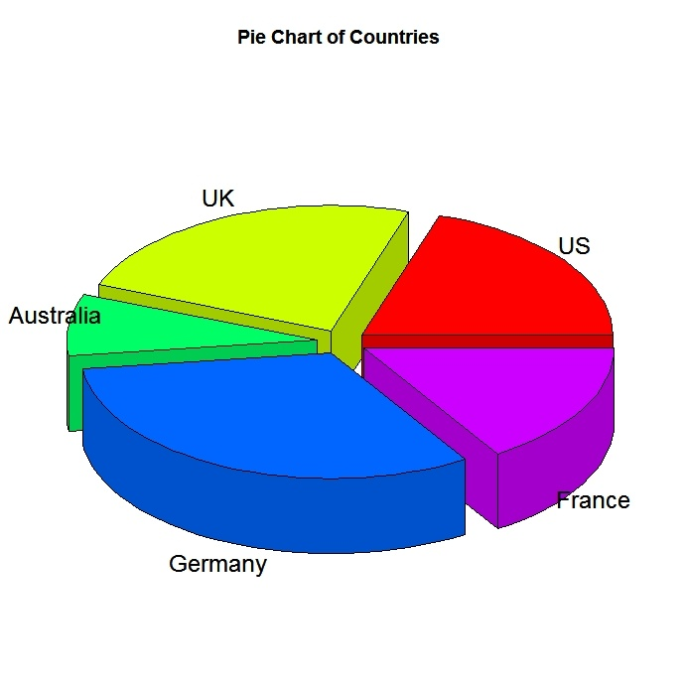

Creating Annotated Pies from a data frame

# Pie Chart from data frame with Appended Sample Sizes  
mytable <- table(iris$Species)  
lbls <- paste(names(mytable), "\n", mytable, sep="")  
pie(mytable, labels = lbls,   
   main="Pie Chart of Species\n (with sample sizes)")

